Feedback Loop Booklet

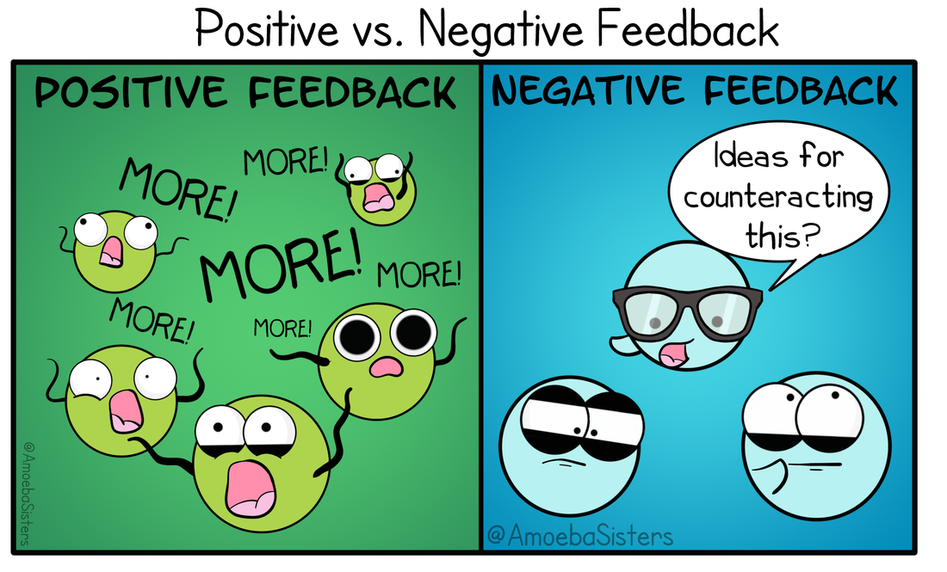

Name: _________________

Checklist:

- Too hot
- Too cold
- Too much CO₂/Not enough O₂
- Too much water
- Not enough water
- Blood sugar too low
- Blood sugar too high

